

***Howick Little Theatre, in association with Creative Communities/Auckland Council, is proud to bring you***

**The Actor’s Voice**

**An Advanced Workshop** with **internationally trained voice and performance coach Kirstie O’Sullivan**

**Where:** Howick Little Theatre, Lloyd Elsmore Park, Sir Lloyd Drive, off the Pakuranga Highway, Pakuranga

**When:** **May 20-21, 10am-4pm (both days).**

**Cost:** $65 (includes workbook for each participant).

(Limited to 10 people aged 18 and over.)

**It is preferable that you have done The Actor’s Voice: Level 1 (or similar, by application). Please do NOT make a payment without first checking that places are available. Email**[**info@hlt.org.nz**](mailto:info@hlt.org.nz)**to book your place now.**



**Don’t miss this wonderful opportunity.**

This is an advanced course created for actors who wish to expand their understanding and application of vocal practice in performance and build their confidence. Please note places are strictly limited in order to provide all participants with personal attention and feedback.

**BRIEF OUTLINE OF COURSE:**

The Actor's Voice: Level 2 consolidates and expands on the fundamental discoveries and practice introduced in The Actor's Voice: Level 1.

Explore the integration of Voice & Language while deepening your understanding of the creative power of your own voice. What better way to do this than with the works of William Shakespeare?

Remove the distance between you and Shakespeare's text and build your confidence in this weekend workshop. Through a broad range of exercises you will explore the integral links between impulse, body, breath, voice and language while increasing your ability to safely and effectively access an expressive, powerful and fully embodied voice.

During The Actor's Voice: Level 2 you will...

* Explore how your voice can help you approach text in a physical & visceral way
* Learn what it takes to fill space vocally, physically and imaginatively in performance
* Release and extend the power of words, using a selection of Shakespeare's texts
* Become an 'emotional detective' and learn how to read Shakespeare's secret acting cues
* Troubleshoot vocal challenges as they arise in the moment
* Extend your vocal resonance, range and reach
* Explore and present a Shakespearean monologue
* Receive clear, direct and immediate feedback to help accelerate progress.

**You’ll Need:** to bring lunch. Also pen and paper and a 2-3 minute monologue to work on.

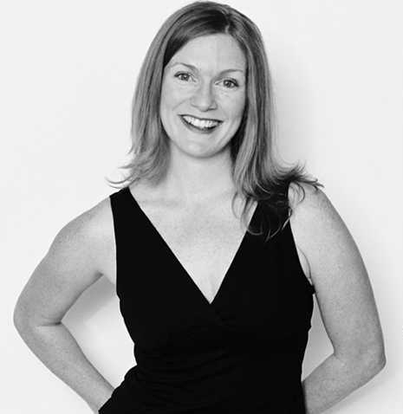**Background: KIRSTIE O’SULLIVAN**

Kirstie is a voice and performance coach based in Auckland, New Zealand. She was the founding Head of Voice for The Actors' Program and has coached voice for ATC, Silo

Theatre, MASSIVE Company, Auckland Shakespeare Company and Pop-up Globe Theatre. Kirstie has also worked extensively with film and television production companies throughout Aotearoa. She regularly lectures in voice and communication training at Auckland and Waikato Universities and has been on the faculty of the annual New Zealand Law Society Litigation Skills programme since 2010. Kirstie is also Director of The Voice Practice which specialises in media and communication coaching, voice and performance coaching and business presentation skills.

**Workshop Registration Form**

Send to: [info@hlt.org.nz](mailto:info@hlt.org.nz) or HLT, PO Box 82-003, Highland Park, Auckland, 2143.

Name:........................................................................................Age:.............................

Address:...................................................................................................................

Email:.......................................................................................................................

Contact phone number:........................................... (evenings)

Daytime: ........................................... Mobile :........................................................

I wish to register for:

THE ACTOR’S VOICE Level 2 WITH KIRSTIE O’SULLIVAN

O I have already done The Actor’s Voice workshop with Kirstie YES/NO

O I have done another voice workshop that I believe will qualify me to do this advanced workshop. Please give details:

................................................................................................................................  
  
.................................................................................................................................

O I am interested in more information about the theatre.

O I require a receipt for this workshop.

**Once we receive your registration form, you will receive confirmation of your place on the workshop and be asked to pay the $65 registration fee in one of two ways, either by direct credit or by sending us your credit card details. If, however, all the spaces are already filled, you will be notified that you are on the waiting list for a place.**

**I understand that if for any reason I am unable to attend, a refund cannot be made unless the vacancy can be filled. (Please advise the office ASAP if you are unable to attend.)**

Signed:______________________________________

~~~~~~~~~~~~~~~~~~~~~~~~~~~~~~~~~~~~~~~~~~~~~~~~~~~~~~~~~~~

**“Kirstie has an almost forensic perception of what is needed and is able to tailor this knowledge to each person she works with. She knows the human voice inside and out and, in an entirely positive way, is able to bring each actor to an awareness of any issues they may have and provide them with practical techniques and exercises that will both maintain and strengthen their vocal power.”**

* ***Michael Hurst, actor and director***